Skitch Instructions
This app is great for creating diagrams.
- If you have an evernote account you can sign in to link the two. Otherwise you can skip this step.

- Create a new project. Decide where the image is going to come from and select from the options. For my example, I used a photo from my camera roll by selecting “choose a photo”.
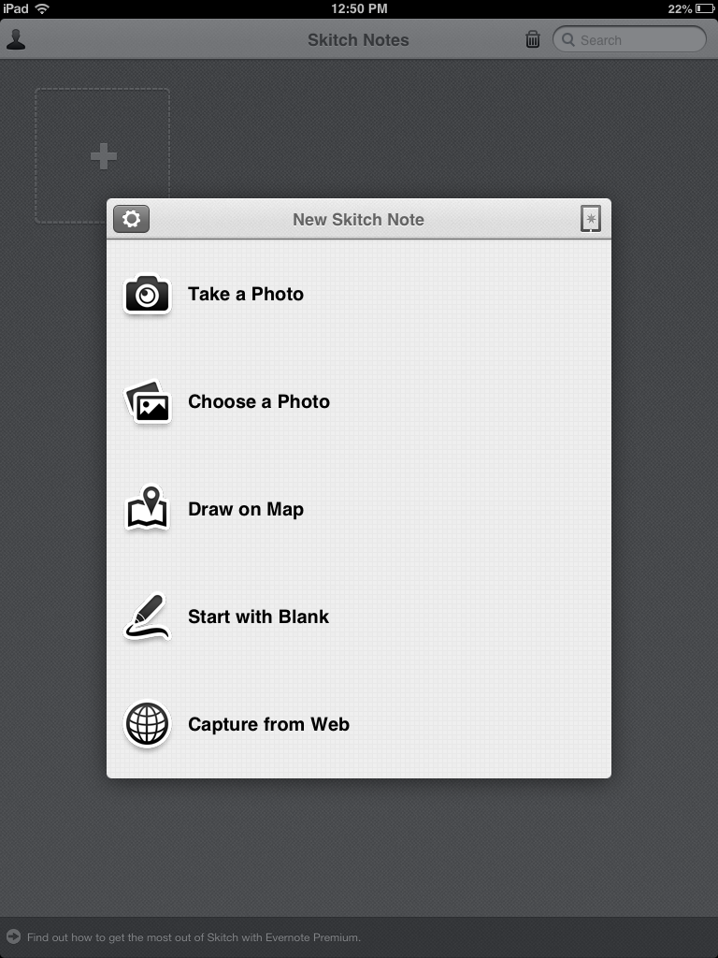

- Once you select your image you will see it displayed in the screen, just like mine is below:
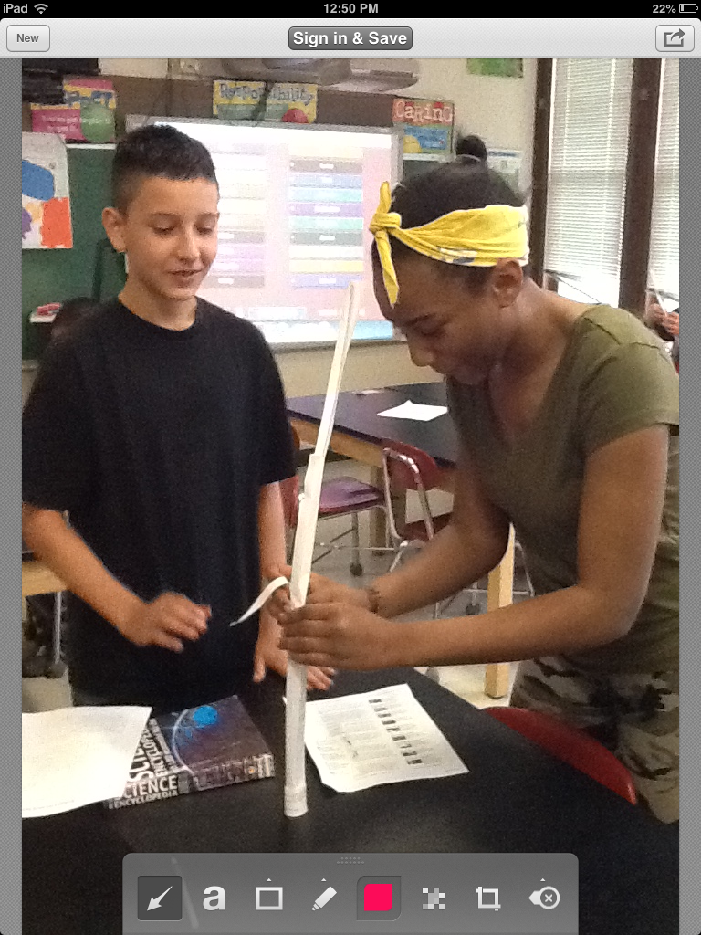
This draws arrows. To change the arrow color select the color first before hitting the arrow button.
Creates text boxes
Draws shapes
Marker/highlighter
changes marker, arrow, and font colors
Pixelates part of the photo
crops
Adds notes

- Add things to your Skitch by using the toolbar at the bottom.
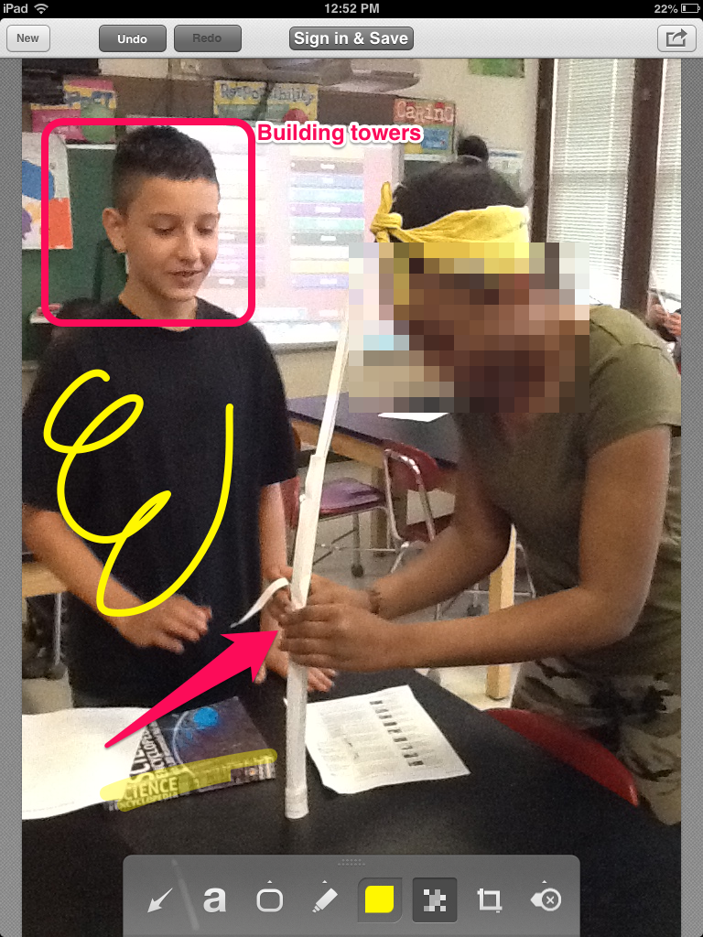

- Save your work. I like to save it to the camera roll so I can upload it to Edmodo.



