Science360
This app takes a minute to load due to the numerous video and images. The screens are randomized and change roughly every week. Unless you are just browsing be sure to save anything you want to find again.
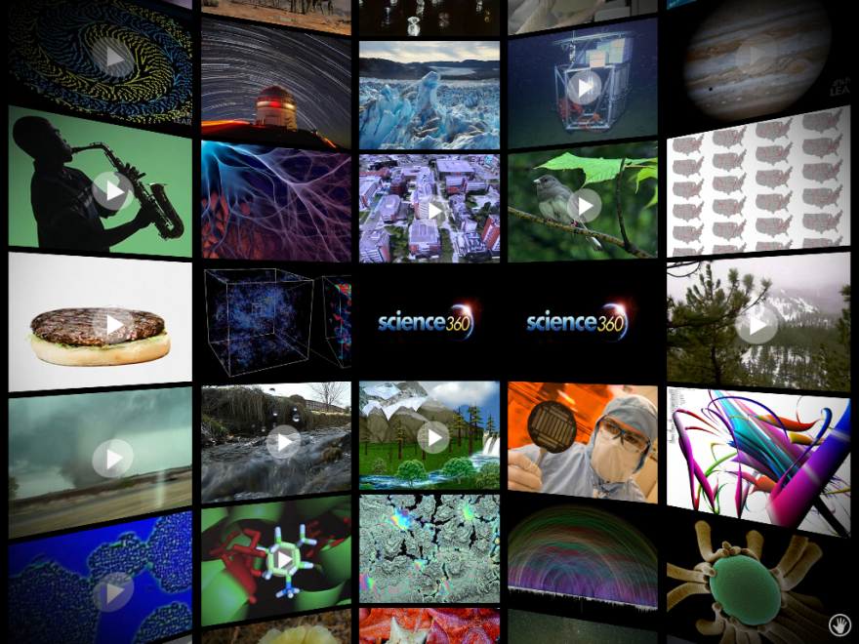
Drag the screen up, down, left, or right to view all the featured videos and images. You will notice that the screens make a sphere (hence the 360) so you will come back to where you started fairly quickly. Tap on any screen to view the video (denoted with a play sign) or photo.

For a quick reference on the finger controls, tap the hand in the bottom right corner.

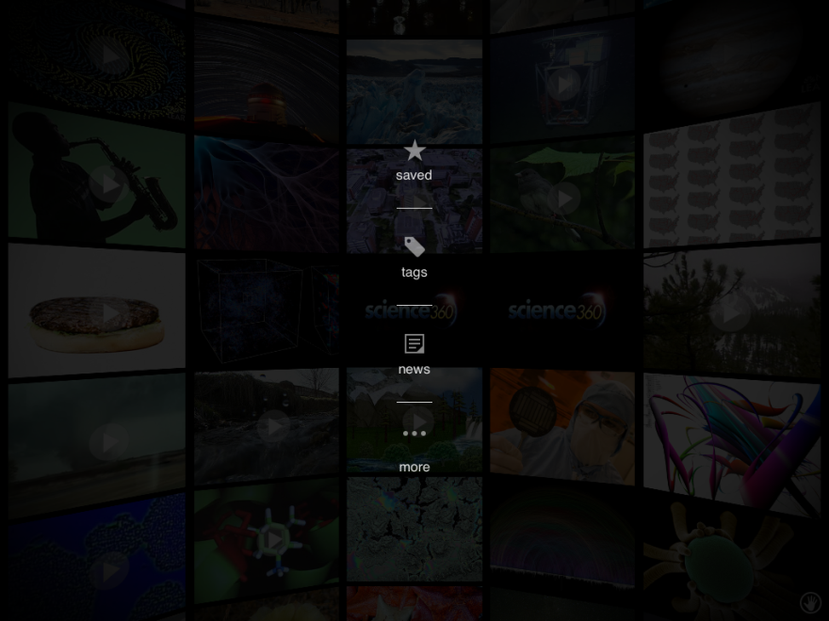
Tap with two fingers to get more option. The star is where all videos or images saved on that iPad are kept. There is no account log in. Anyone can save in this app and anyone can see saved videos.

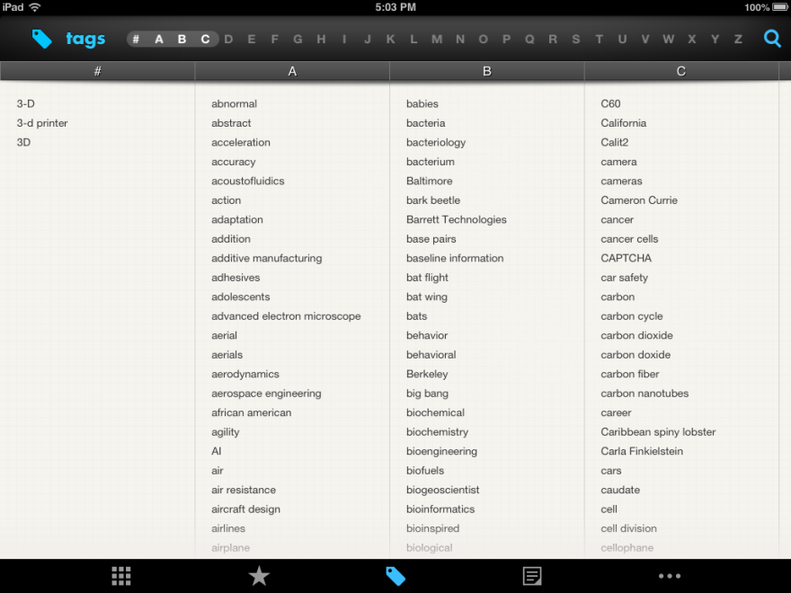
Tags allow you to search by topic. You can type in a topic at the magnifying glass or select a letter.

This saves a lot of time. Once you find what you are looking for, be sure to save it by tapping the star.

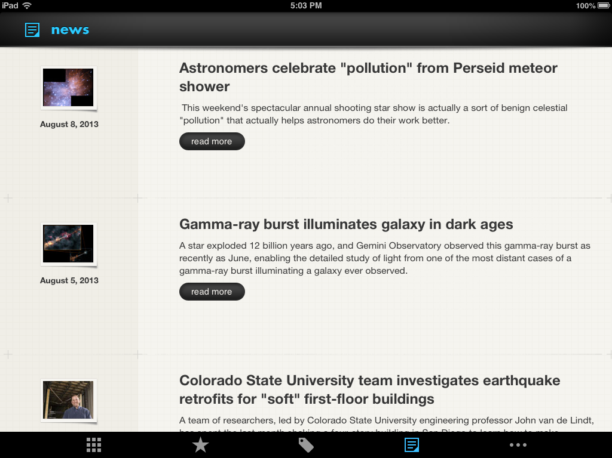
News has the most recent additions to the app organized by date.

