Evernote
This app allows you and your students to save documents, websites, and notes. After logging in, the information can be accessed on any device. The home screen on the iPad app is below. You can find all your notes in the green tabs.
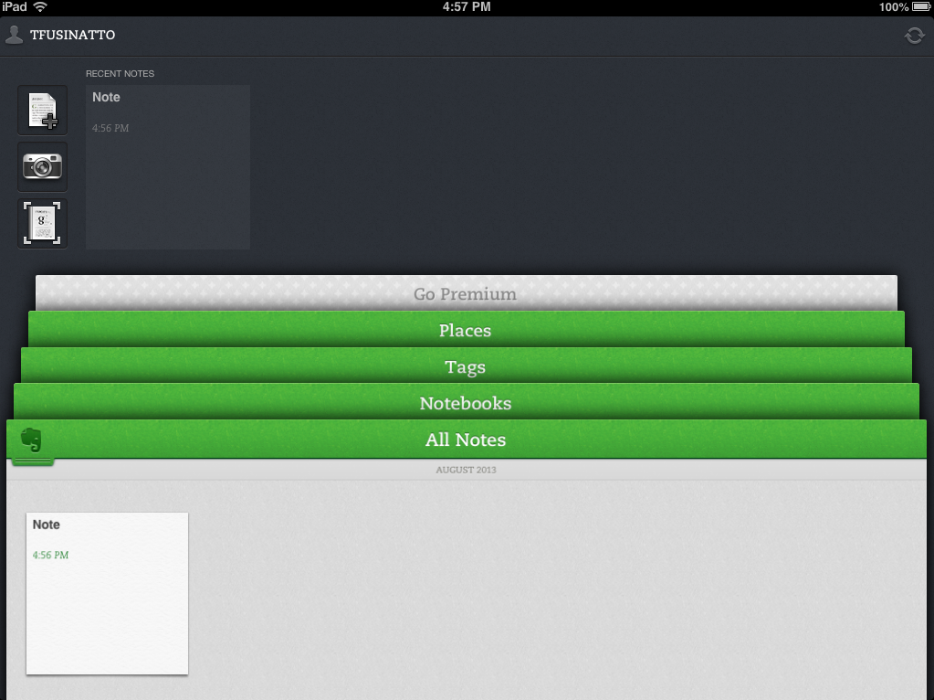
Add a note Save a picture Take a picture of a document to save as a note.
Text in a photo is searchable!!
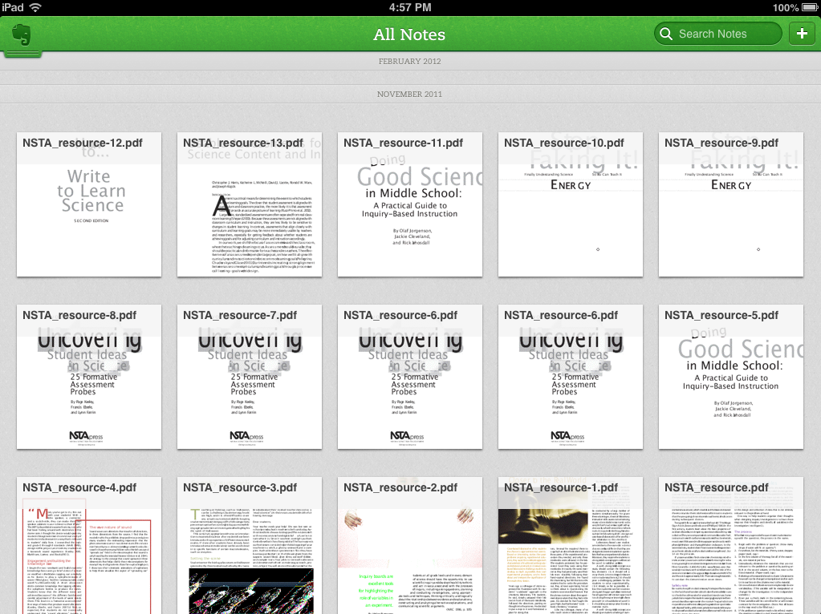

Under the all notes tab, you can see all PDFs, Word documents, or personal notes. You can search the text of all notes.

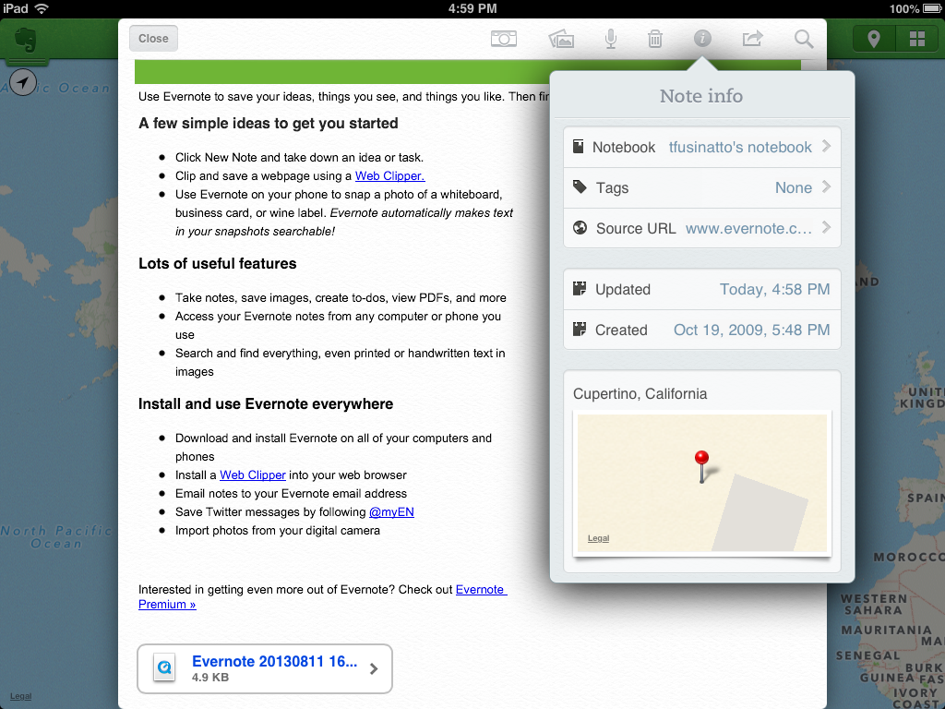
Under the places tab, you can view all notes that have been linked to a place. You link a place within note info.

Audio can be recorded for each note by tapping the microphone at the top of the note. The audio file is saved as a Quicktime file within each note.
Pictures can be linked either by taking a photo with the camera (tap the camera at the top of the note) or use the camera roll (tap the stacked photos at the top of the note).

