Edmodo
Home Page
Nearly everything you want to do can be completed from your homepage. You can see all of your groups, communities, and most recent posts from them.

You can access your Edmodo apps on the far right icon of stacked boxes. You can shop for apps by selecting the shopping cart on the far right.
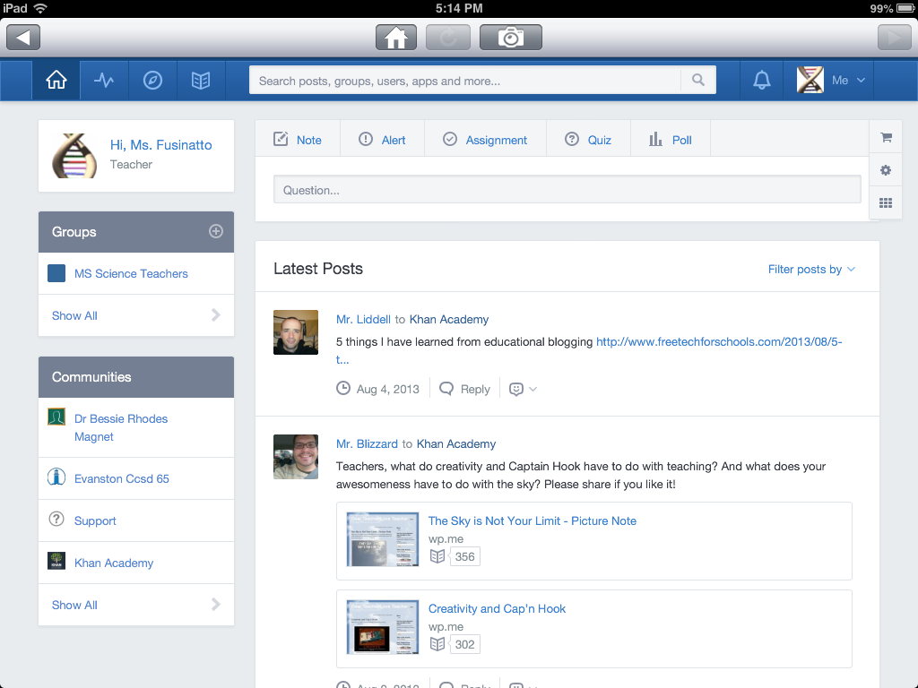

To create a new group or join an existing group, select the plus sign next to the “Groups” tab. In order for you or your students to join a group, you will need the code for that group. For groups you create the code appears when you tap on the group’s name. To manage your groups, tap on the group’s name.

Group Settings
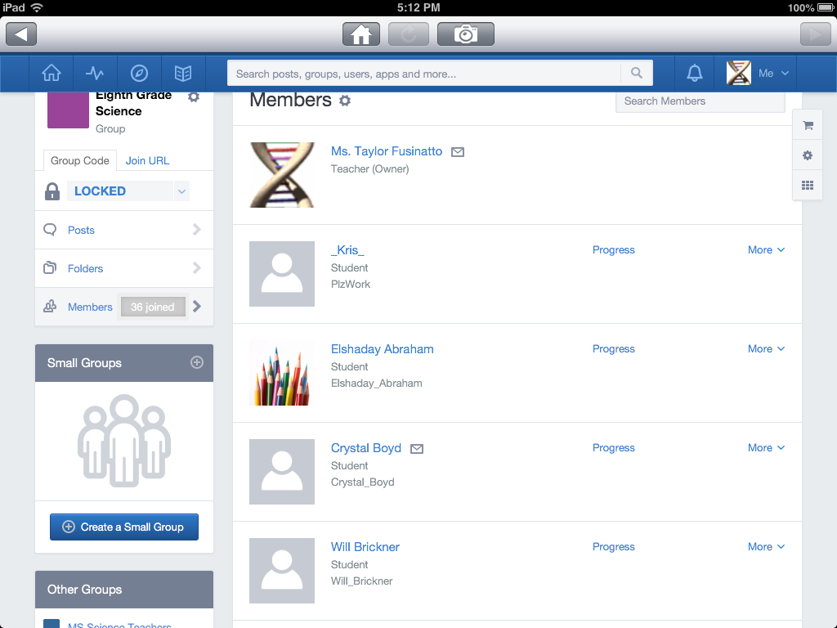
- Once all students have joined a group, you can lock the code so other people cannot join.
- You can review the whole group’s activity and work by selecting the “Posts” and “Folders” tab on the far left.
- You can view all members of the group and their progress on assignments and Edmodo activity.
- Within each group, you can create small groups for projects or studying. Select the blue “Create a Small Group” button. Students can be a part of several small groups.

Posting to groups
To post a note to a group, on your home page tap “Note”. After typing your note, you can select which group(s), small group(s), or individual(s) to whom you are sending the note. This is the same for the students. It is very important to remind them to be aware of which group they are posting to, as being a member of multiple large groups and small groups can get confusing. Students cannot post to individuals.

You can attach files, websites, and documents in you library to the note. The clock option allows you to schedule the message to be delivered at a specific time and day.

To post a poll/survey question to a group, on your homepage tap the “Poll” tab. Type in the question and possible answers.
After typing your poll question, you can select which group(s), small group(s), or individual(s) to whom you are sending the survey.
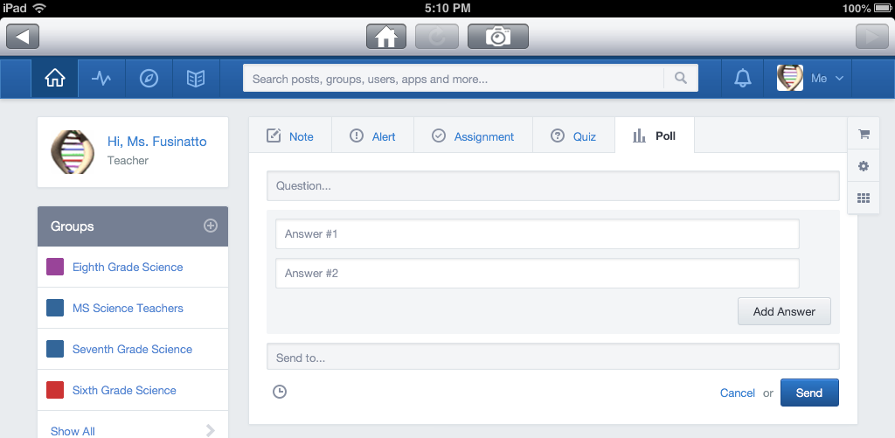

The clock option allows you to schedule the poll to be delivered at a specific time and day.

To post an alert (reminder) to a group, on your homepage tap the “Alert” tab. Type in the message and select which group(s), small group(s), or individual(s) to whom you are sending the reminder.
The clock option allows you to schedule the alert to be delivered at a specific time and day.
To post an assignment to a group, on your home page tap “Assignment”. Name the assignment, type in the directions, and insert a due date. After typing your directions, you can select which group(s), small group(s), or individual(s) to whom you are sending the work.

You can attach files, websites, and documents in you library to the note. The clock option allows you to schedule the assignment to be delivered at a specific time and day.

To post a quiz to a group, on your homepage tap the “Quiz” tab. To make a new quiz, select create a quiz. If you already have quizes made on Edmodo, select load a previously created quiz.
To create a quiz, develop different questions, set a time limit, and leave yourself a note describing the quiz and its content. Then assign the quiz.
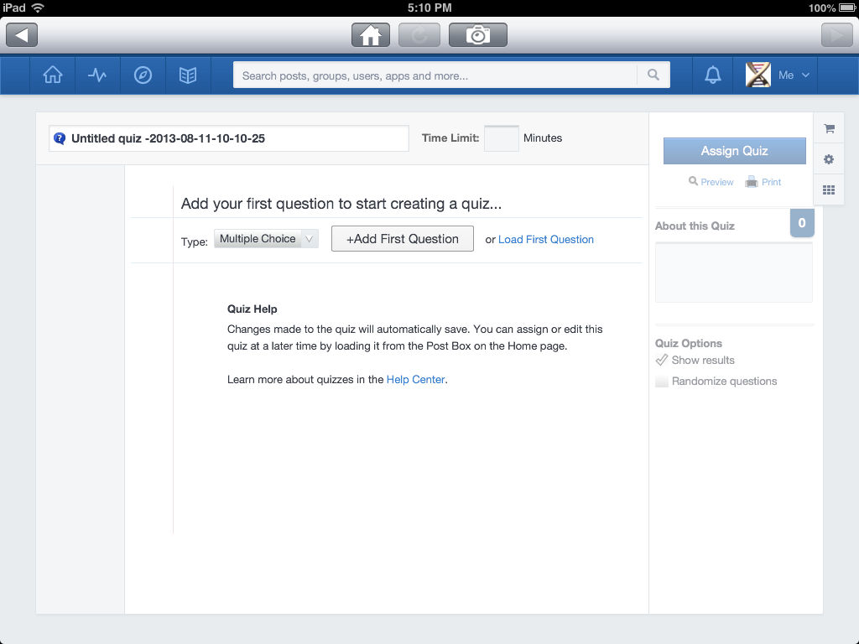

Check student progress
Select the zigzag line on your homepage and choose a group to monitor.

On the progress page, you can monitor the grades and turned in assignments under the grades tab.

Under the insights tab, you can review trends in your classes. This page posts the most common student reactions to different assignments over time. You can also review your reactions to student work, the most active students, and what has been viewed the most.

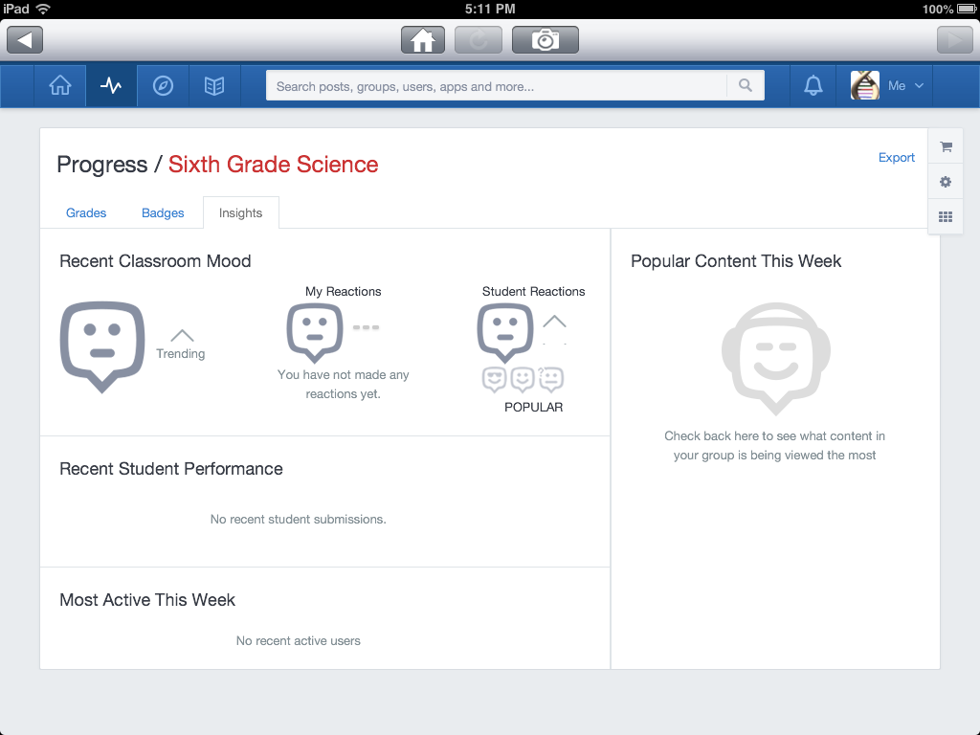
Review student badges earned for completing different tasks.
Create student badges or use pre-made badges from Edmodo to help students visually track their progress. Select “My Student Badges” under the progress menu.

